**FoodBox**

Phase 5 Assessment

Source Code

Name: Harshitha G M

Cohort: MS FSD June 2022 Cohort 3

GitHub link: https://github.com/HarshithaGM01/Phase-5-Foodbox.git

Contents.

1. User Flow Chart Diagram 3
2. GitHub Link… 4
3. Database Design… 4
4. Folder Structure… 6
5. Project Files… 11

# User Flow Chart Diagram.

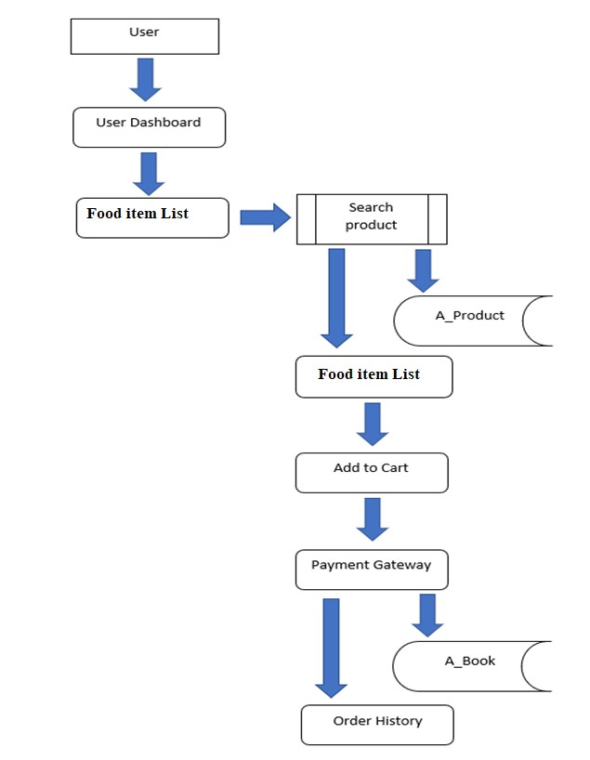

1. ***GitHub Link.***

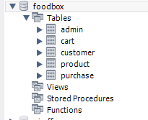

***3. Database Design.***

https://github.com/HarshithaGM01/Phase-5-Foodbox.git

Data Result Set:

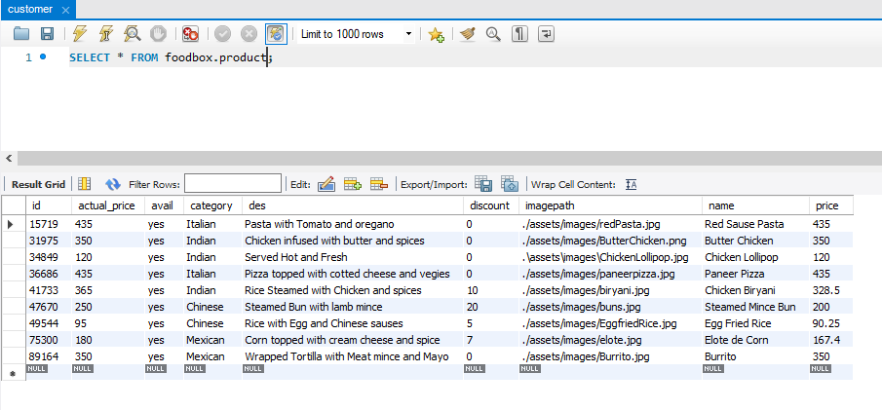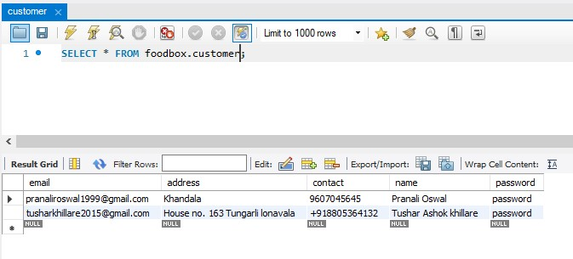

1. ***Folder Structure.***

**(Back End Development)**

Spring Project Structure

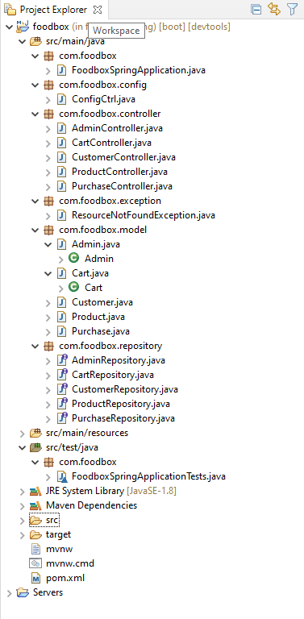

Pom.xml

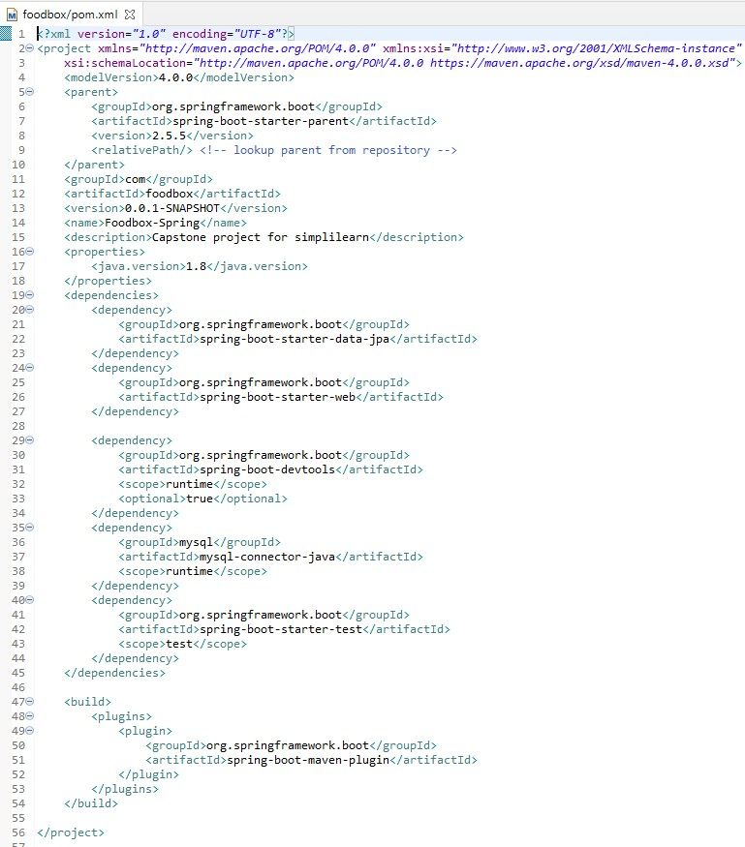

FoodSpringApplication.Java

FoodboxSpringApplicationTests.Java

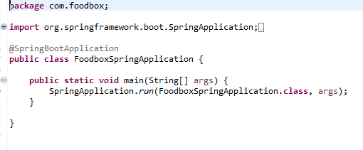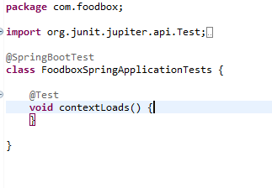

Rest of the files are present in the given GitHub link kindly refer this…

### https://github.com/jadhavservices/Foodbox

Spring Output:

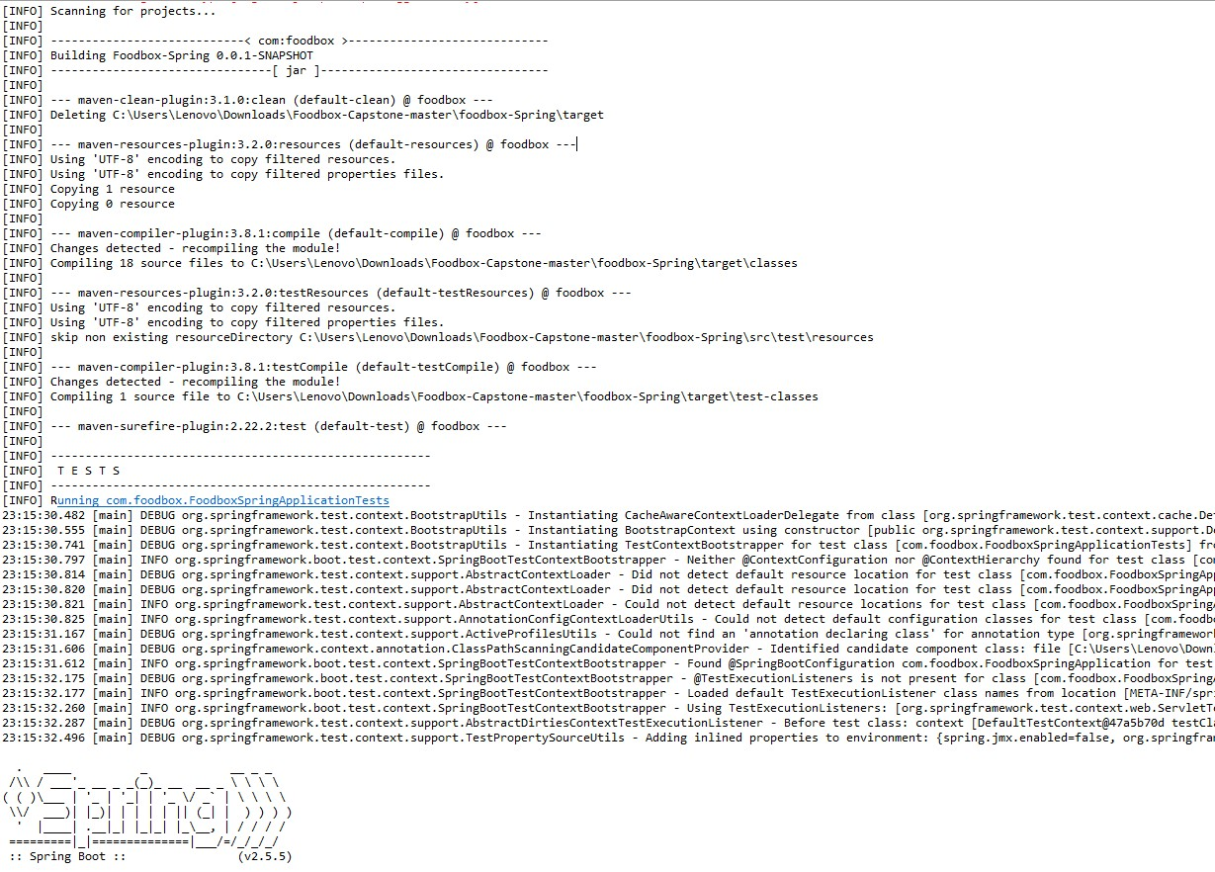

**(Front End Development)**

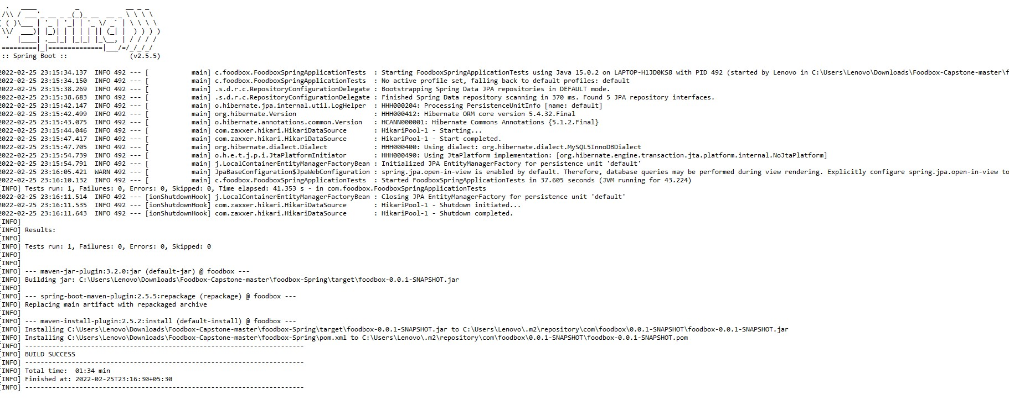

Angular Project Structure:

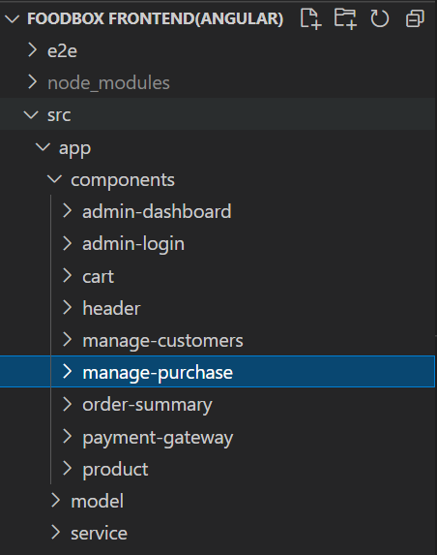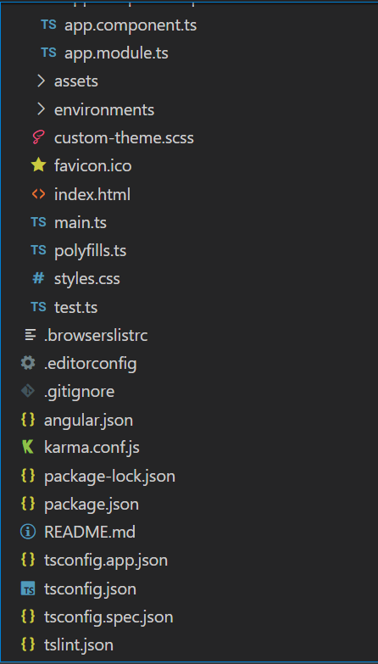

1. ***Project Files.***

Index.html

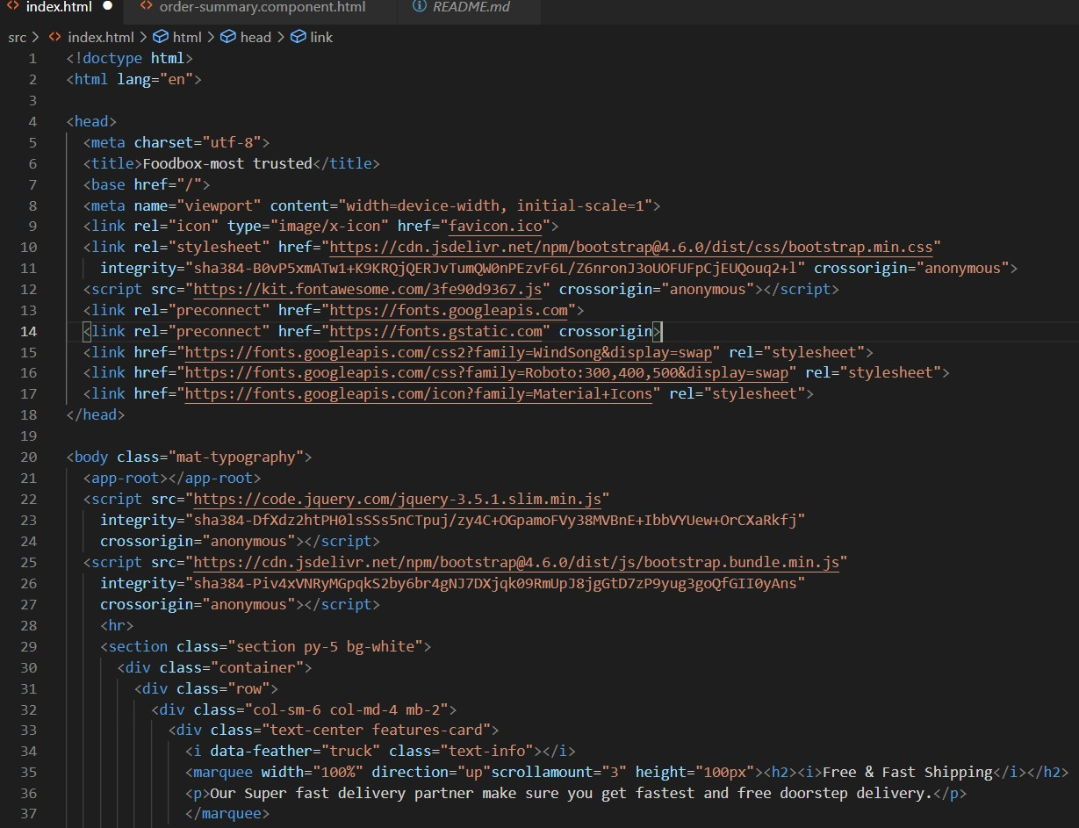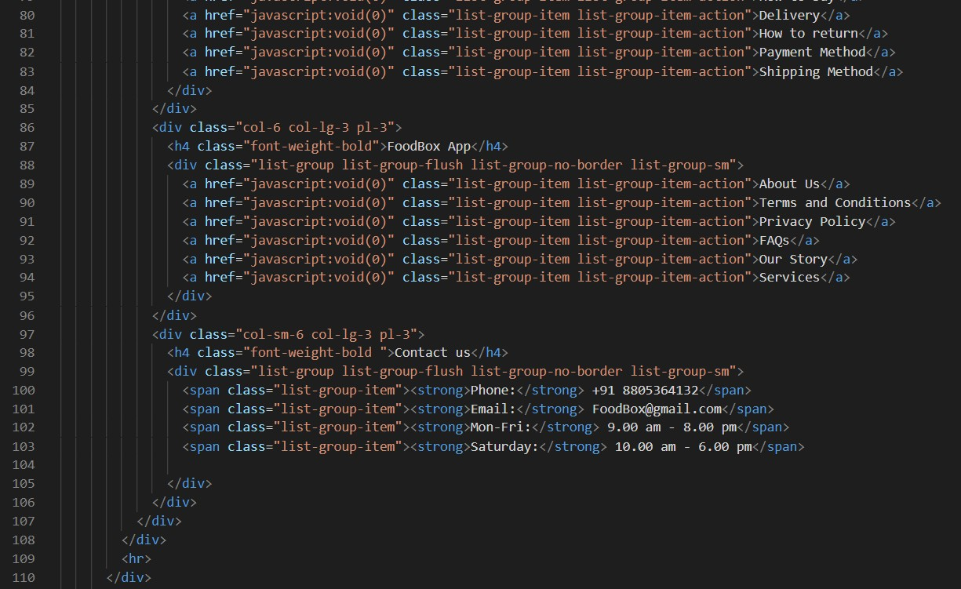

test.ts:

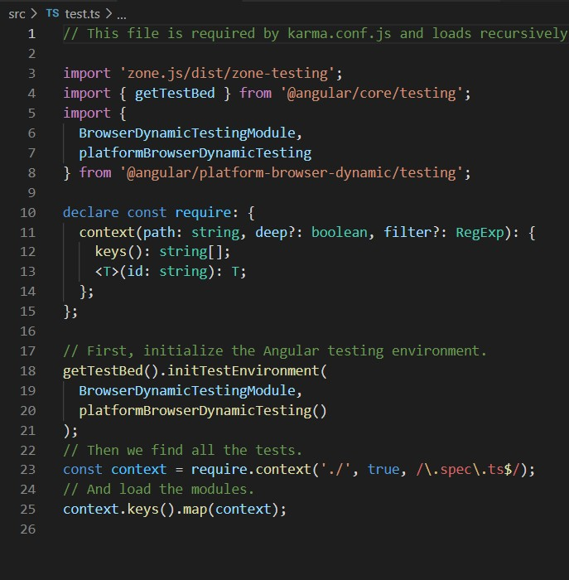

## Package.json:

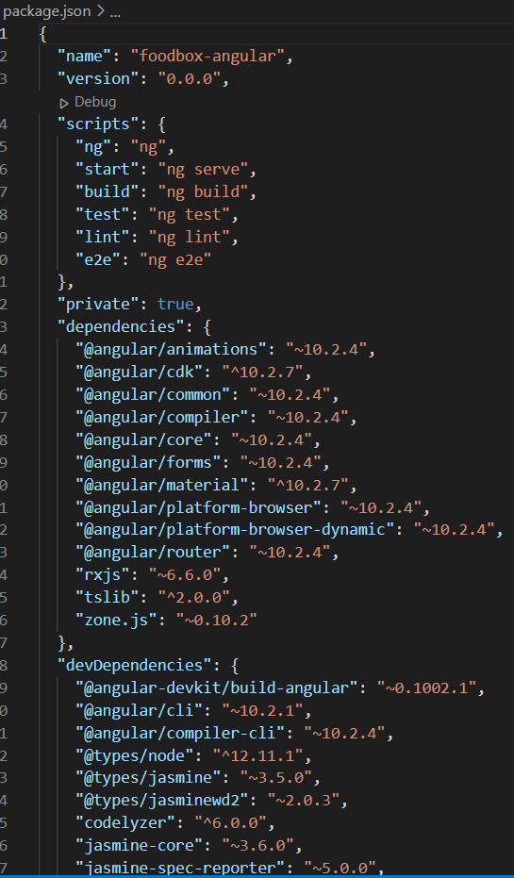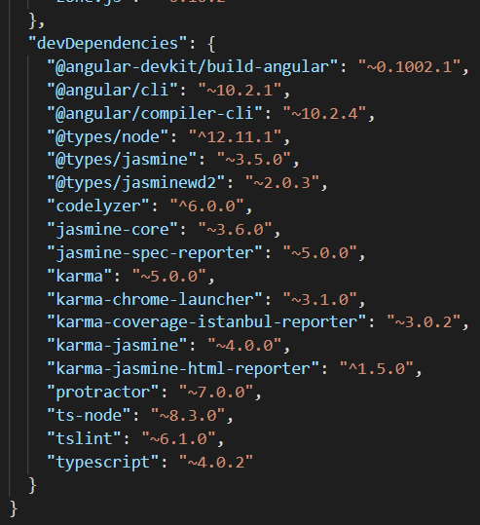

Angular Outputs:

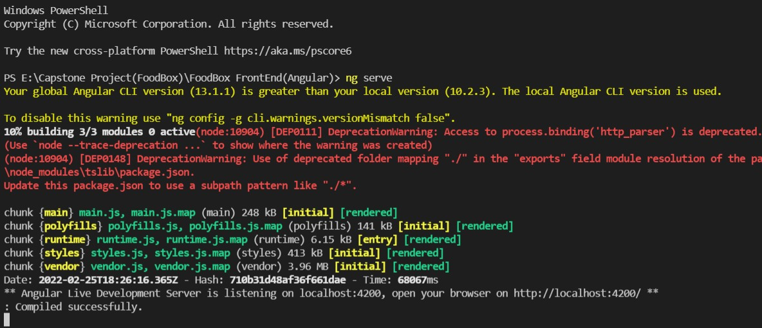

THANK YOU……………